You have two options when creating custom controls:

1. Create your own control based on an existing Standard UI5 Control
2. Create your own control from scratch

The example below is about the second one.

Actually this example was a real life problem for me.After writing several applications on HR and copy-paste the same fragment to almost all my projects, I decided to make it a custom control..And now when the customer wants a change, the only thing we do is just change our custom control..

Example control is Personel Object Header..At the end of the document, you will be able to add the below Object Header to your project just like adding a new Label..

[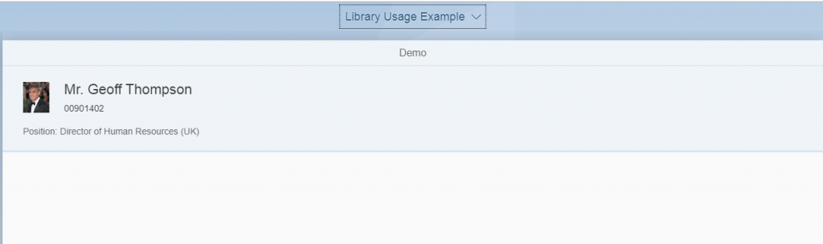](http://zyndanismanlik.com/wp-content/uploads/2019/11/11.png)

First of all, you need to create a SAP Fiori Library project.

[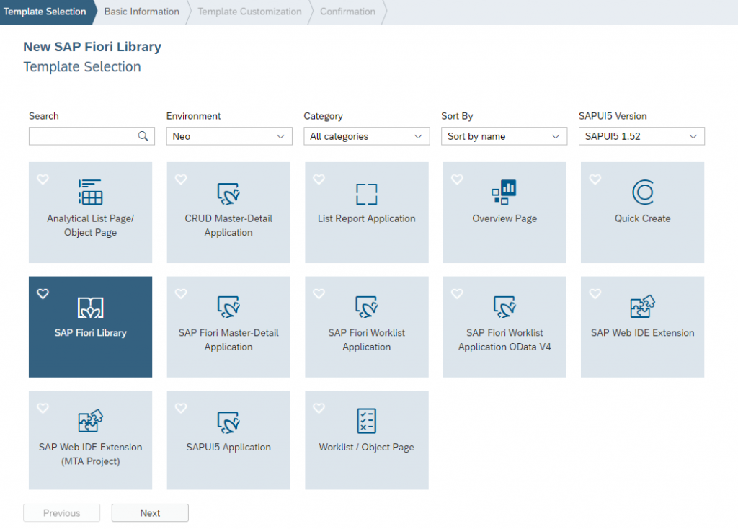](http://zyndanismanlik.com/wp-content/uploads/2019/11/1.png)

Give your project a name..

[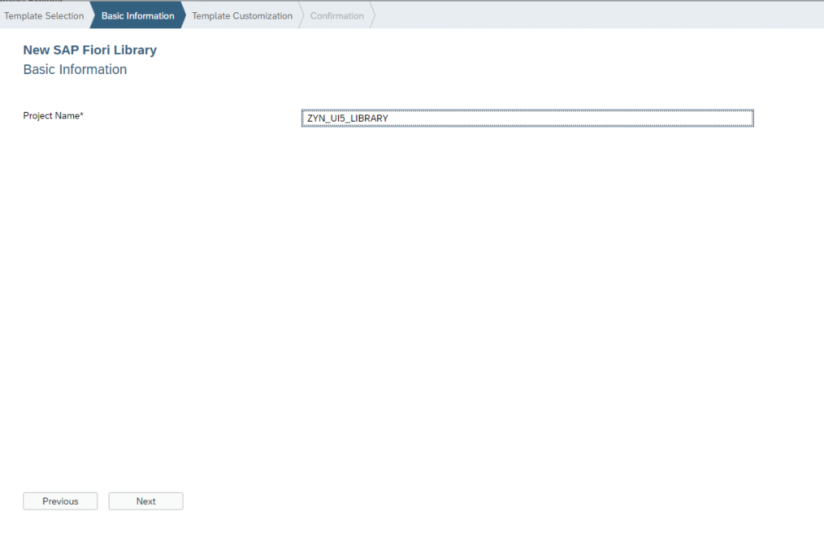](http://zyndanismanlik.com/wp-content/uploads/2019/11/2.png)[tablo içeren bir resim

Açıklama otomatik olarak oluşturuldu](http://zyndanismanlik.com/wp-content/uploads/2019/11/3.png)

When you finish, you will have a project structure like below..

[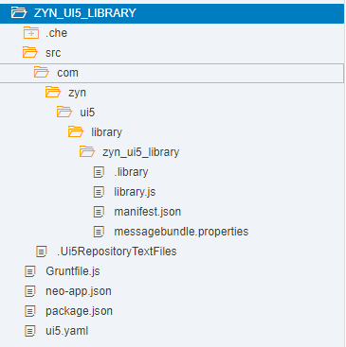](http://zyndanismanlik.com/wp-content/uploads/2019/11/4.png)

Create your new control

[metin içeren bir resim

Açıklama otomatik olarak oluşturuldu](http://zyndanismanlik.com/wp-content/uploads/2019/11/6.png)[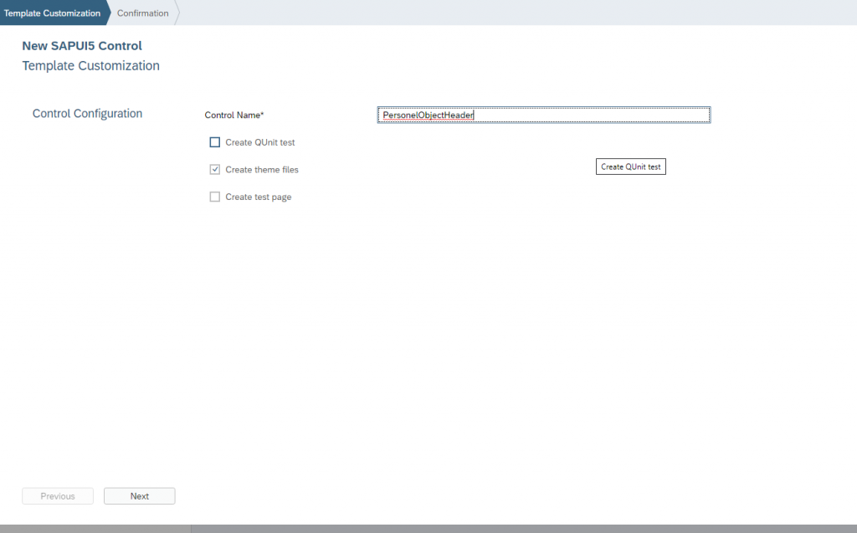](http://zyndanismanlik.com/wp-content/uploads/2019/11/7.png)

And add Object Header fragment like below. For simplicity, I just added 2 attributes: Organisation and Position..

[metin içeren bir resim

Açıklama otomatik olarak oluşturuldu](http://zyndanismanlik.com/wp-content/uploads/2019/11/8.png)

Change PersonelObjectHeader.js like below.. We have 3 properties in our control: Pernr, OrganizationVisibility(default:true) and PositionVisibility (default:true) ..

[metin içeren bir resim

Açıklama otomatik olarak oluşturuldu](http://zyndanismanlik.com/wp-content/uploads/2019/11/9.png)

Change PersonelObjectHeaderRenderer.js like below.. Calling OData service for setting “personel” model and getting the visibility properties from the control in order to set “view” model..

[metin içeren bir resim

Açıklama otomatik olarak oluşturuldu](http://zyndanismanlik.com/wp-content/uploads/2019/11/10.png)

Deploy the app to your ABAP repository and that’s it..You have a brand new library containg your own custom control..

Let’s use it in a project!!

Create an empty project and Add Reference to Library like below.

[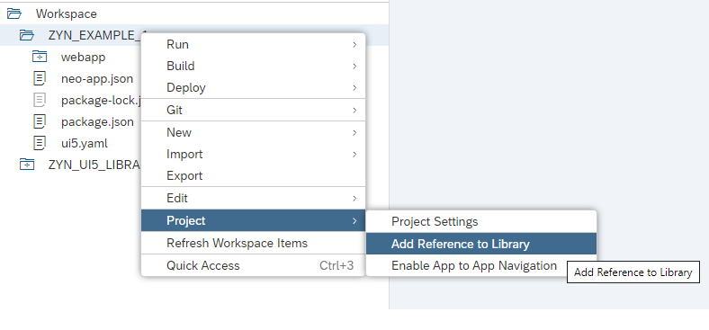](http://zyndanismanlik.com/wp-content/uploads/2019/11/12.png)[tablo içeren bir resim

Açıklama otomatik olarak oluşturuldu](http://zyndanismanlik.com/wp-content/uploads/2019/11/13.png)

Open your view and add the below code;

[metin içeren bir resim

Açıklama otomatik olarak oluşturuldu](http://zyndanismanlik.com/wp-content/uploads/2019/11/14.png)**Notice that OrganizationVisibility is false!!**

Test your app and voila!!

[](http://zyndanismanlik.com/wp-content/uploads/2019/11/11.png)